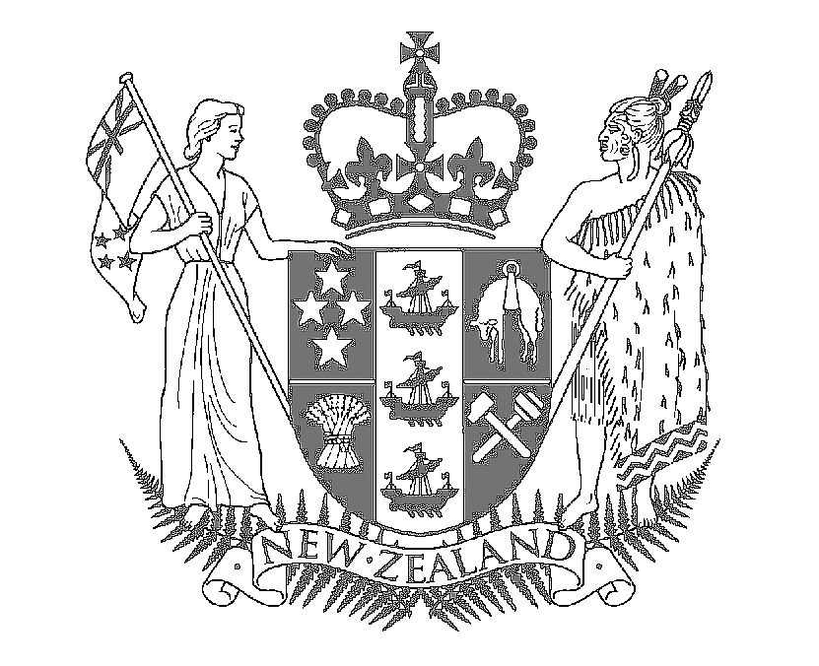

Speech Notes

HON MAHARA OKEROA
Associate Minister for Arts, Culture and Heritage

SPEECH FOR THE FISHERMEN’S DAUGHTERS EXHIBITION OPENING

18 AUGUST 2008

Acknowledgments to:
Gael Ramsey
Ramonda Te Maiharoa
Irene Mura Schroder

Kia ora koutou,

Greetings to everybody and what a great pleasure and privilege it is to be here for the opening of the Fishermen’s Daughter Exhibition.

Tonight’s event is a celebration of art and an opportunity to recognise and celebrate the importance of identity, friendship and home.

Over the years, the arts sector has been a vital element to helping us embrace our cultural identity. Through the arts we explore what it means to be a New Zealander, which ultimately helps contribute to the growing body of our culture.

Ideas about what contributes to our identity have changed a lot as we have become more comfortable with ourselves.

I understand the recent Searching for an Identity exhibition attracted over 17,000 visitors. These large numbers are a testament of the interest in this issue and I’m sure the same enthusiasm will be evident with this exhibition.

Many different peoples now contribute to New Zealand identity, and we can recognise and celebrate each one of them. Our creative people can both reflect and contribute to the shaping of our identity. And we as an audience can view, appreciate and share what the artists are giving us.

Of critical significance perhaps is our growing willingness to acknowledge both mana whenua and our growing diversity as key components of what defines New Zealand in the 21st century. Diversity is what makes our culture rich and vibrant.

I understand the inspiration for this exhibition is the enduring friendship of Ramonda and Irene, which started in their childhood in Bluff, and continued even when they were when living abroad for many years. That friendship is a treasure that they have now handed to us and future generations.

These two, like many New Zealanders, have set off on a voyage of self-discovery, only to realise that the anchor of home was pulling them back.

I am pleased that the pull of their New Zealand heritage made them return home. This exhibition is all about the importance of home to all of us. For the Fishermen’s Daughters, home is about the strength and beauty of the southern coastline and its people, captured in Ramonda's photomontage images and Irene's clay sculptures.

The photographs capture time and space in images that resonate for those of you who know these places, and give others insight into how Ramonda experienced them.

And Irene’s work is all about where earth and water meet. As New Zealanders, we can all relate to that. Most of us live near water and have a deep affinity with our rivers, lakes and beaches.

I would like acknowledge the Southland Museum and Art Galley for hosting this exhibition; the Gallery recognises the cultural identity and place of the tangata whenua in the region and has stimulating and diverse exhibitions to inspire future local artists.

The Gallery is helping to preserve and tell the story of Southland – the experience of people and places over time – and to inspire Southlanders to explore and understand the world around them.

This is another example of the Gallery looking to the future in terms of the collections and buildings, as the Gallery continues playing an important role in this community by providing a venue for collections that represent historical and contemporary artistic and creative development, thought and expressions.

In closing, I would like to congratulate Irene and Ramonda, and all those who have had a hand in curating and setting up this exhibition.

I am very honoured to open the Fishermen’s Daughters exhibition and I wish you every success.

